Radiation and Antennas Homework (30 Points)
(jas, Radiation and Antennas HW.docx, 12/05/2025)

Use units and clearly label answers using 3 or 4 significant digits where appropriate. Show your work so that if necessary partial credit can be awarded.

- Using your own words and complete sentences, explain what an isotropic transmit antenna is. (2 points.)

An isotropic antenna is a theoretical antenna that radiates equally in all directions. As we learned in class, the only isotropic radiation that we know that exists in our world is the sun, ignoring sunspots and flares.

- Using your own words and complete sentences, explain why the EM radiation from an isotropic transmit antenna is not uniform with distance. (2 points)

The radiation from an isotropic antenna is not uniform with distance because of how the power dissipates. This can be represented as a cone, with the point facing the antenna. As the signal radiates, the flat face of the cone grows, so the same amount of power is dissipated over a larger area. This cone surface does not increase uniformly with distance, but is proportional to the radius of the circle.

- Calculate the solid angle in steradians for a hemisphere, showing your work and including units in your final answer? (3 points total. 2 points for shown work. 0.5 points for units.)
$$Ω_{hemisphere}=\frac{A}{R^{2}}=\frac{2πR^{2}}{R^{2}}=2π sr$$
$$Ω_{hemisphere}=2π sr$$

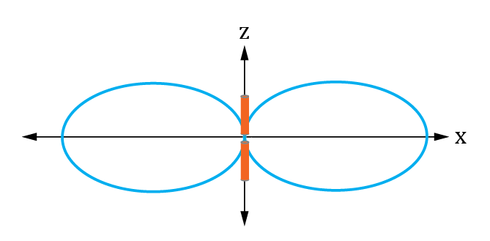
- Using MATLAB, generate an m-file to produce a 2-D plot in the x-z plane of normalized radiation intensity versus distance from the origin for a half-wave dipole antenna, as shown in the adjacent figure.

The resulting 2-D plot represents the normalized radiation intensity versus distance from the origin, with longer distances representing larger magnitude radiation intensities. For the half-wave dipole antenna, the normalized radiation intensity in spherical coordinates is given as follows:

$$F\left(θ\right)= {\left\{\frac{cos\left[(π/{2)}cos\left(θ\right)\right]}{sin\left(θ\right)}\right\}}^{2} (Eq. 9.46)$$

where θ is defined as the elevation angle with respect to the z-axis, i.e. θ = 0 corresponds to the R vector in spherical coordinates pointing along the positive z-axis. Because a half-wave dipole antenna is symmetrical about the dipole axis z, the above equation is not a function of the azimuth angle $∅$. The azimuth angle $∅$ corresponds to the angle the R vector in spherical coordinates makes in the x-y plane. To generate this 2-D MATLAB plot, first generate the vector θ (theta) using the linspace(0, 2*pi, 100) function, which generates a 100 point vector ranging from 0 to 2*pi radians. Then set the $∅$ (phi) value equal to zero, resulting in a 2-D plot in the x-z plane as illustrated above. Next generate the vector F from the above equation, i.e. $F={\left[\frac{cos\left[{(π}/2)cos\left(theta\right)\right]}{sin\left(theta\right)}\right]}^{2},$ using the previously generated theta vector. A direct implementation of the indeterminate form $\frac{cos\left[(π/{2)}cos\left(0\right)\right]}{sin\left(0\right)}$ results in a value of ∞ for θ = 0. Yet the correct value is 0, arrived at using l’Hopital’s rule. A similar problem exists for $\frac{cos\left[(π/{2)}cos\left(π\right)\right]}{sin\left(π\right)}$ and $\frac{cos\left[{(π}/{2)}cos\left(2π\right)\right]}{sin\left(2π\right)}$, which should also have values of 0. To overcome these problems, it is necessary to set F(1, 1) = 0, and F(1, 100) = 0, after forming the array F from the above equation. The generated theta vector never exactly equals π radians so it is unnecessary to worry about the indeterminate form $\frac{cos\left[{(π}/{2)}cos\left(π\right)\right]}{sin\left(π\right)}.$ The resulting theta, phi and F vector results are for spherical coordinates, which are to be changed to Cartesian coordinates for this plot. The MATLAB sph2cart() function defines θ (theta) differently than many texts, including ours, so a conversion is necessary. Our text defines the elevation angle θ with respect to the z- axis whereas MATLAB defines the elevation angle θ with respect to the x-axis, which is π/2 – θ from our text definition. So the following MATLAB command converts the spherical coordinate values to Cartesian coordinate values:

[x,y,z]=sph2cart(phi,pi/2-theta,F);

The spherical to Cartesian coordinate conversion could also be performed using the coordinate transform relationships given in Table 3-2 of our text as follows:

x = F.*(sin(theta)).*cos(phi);
y = F.*(sin(theta)).*sin(phi);
z = F.*cos(theta);

After the conversion from Spherical to Cartesian coordinates the following plot() function can be used to plot the desired values:

plot(x, z, 'b-'); grid on, axis equal;

The functions xlabel() and ylabel(), along with title() can then be used to generate a plot as shown below. Replace the plot below with your version. (6 points.)
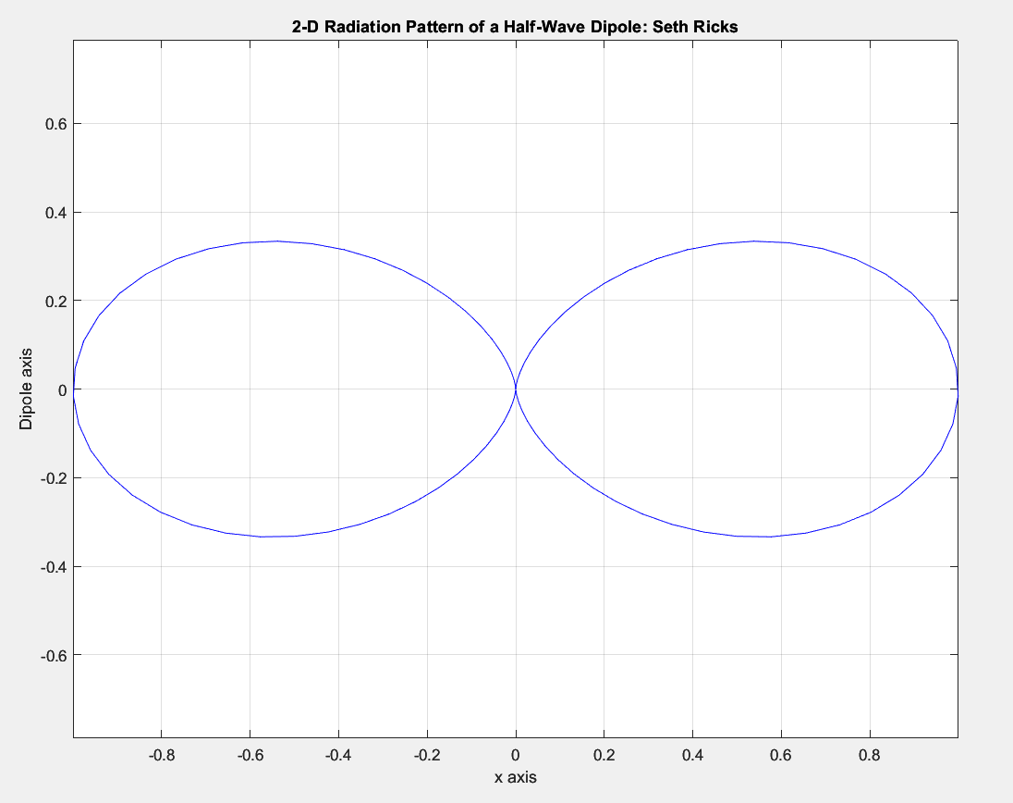

- Using MATLAB, generate an m-file to produce a 3-D plot of normalized radiation intensity versus distance from the origin for a half-wave dipole antenna. The resulting 3-D surface represents the normalized radiation intensity versus distance from the origin, with longer distances representing larger magnitude radiation intensities. For the half-wave dipole antenna, the normalized radiation intensity in spherical coordinates is given as follows:

$$F\left(θ\right)= {\left\{\frac{cos\left[{(π}/{2)}cos\left(θ\right)\right]}{sin\left(θ\right)}\right\}}^{2} (Eq. 9.46)$$

where θ is defined as the elevation angle with respect to the z-axis. Because a half-wave dipole antenna is symmetrical about the dipole axis z, the above equation is not a function of the azimuth angle $∅$, resulting in a doughnut shaped 3-D plot. The azimuth angle $∅$ corresponds to the angle the R vector in spherical coordinates makes in the x-y plane. To generate this 3-D MATLAB plot, first generate the vector θ1 (theta1) using the linspace(0, pi, 100) function, which generates a 100 point vector ranging from 0 to pi radians. Then generate the vector $∅1$ (phi1) using the linspace(0, 2*pi, 100) function, which generates a 100 point vectors ranging from 0 to 2*pi radians. Next use the command [theta, phi] = meshgrid(theta1, phi1), where theta1 and phi1 were the previously generated 100 point vectors. The meshgrid() function converts the 1 x 100 vectors into 100 x 100 arrays, resulting in the 2-D mesh of points necessary for a 3-D plot. Next generate the array F from the above equation using the 100 x 100 theta array generated from the meshgrid() function. A direct implementation of the indeterminate form $\frac{cos\left[{(π}/{2)}cos\left(0\right)\right]}{sin\left(0\right)}$ results in a value of ∞ for θ = 0. Yet the correct value is 0, arrived at using l’Hopital’s rule. A similar problem exists for $\frac{cos\left[{(π}/{2)}cos\left(π\right)\right]}{sin\left(π\right)}$, and $\frac{cos\left[{(π}/{2)}cos\left(2π\right)\right]}{sin\left(2π\right)}$, which should also have a value of 0. To overcome these problems, it is necessary to set F(:, 1) = 0, and F(:, 100) = 0, after forming the array F, where the colon operator applies the result for every row of the array. The generated theta vector never exactly equals π radians so it is unnecessary to worry about the indeterminate form $\frac{cos\left[{(π}/{2)}cos\left(π\right)\right]}{sin\left(π\right)}.$ The resulting theta, phi and F arrays are for spherical coordinates, which are to be changed to Cartesian coordinates for this plot. The MATLAB sph2cart() function defines θ (theta) differently than many texts, including ours, so a conversion is necessary. Our text defines the elevation angle θ with respect to the z- axis whereas MATLAB defines the elevation angle θ with respect to the x-axis, which is π/2 – θ from our text definition. So the following MATLAB command converts the spherical coordinate values to Cartesian coordinate values:

[x,y,z]=sph2cart(phi,pi/2-theta,F);

The spherical to Cartesian coordinate conversion could also be performed using the coordinate transform relationships given in Table 3-2 of our text as follows:

x = F.*(sin(theta)).*cos(phi);
y = F.*(sin(theta)).*sin(phi);
z = F.*cos(theta);

The following MATLAB surface plotting functions are to be used to finally generate the 3-D plot:

surf(x,y,z), grid on, axis equal;
colormap(winter);

The functions xlabel(), ylabel() and zlabel(), along with title() can then be used to generate a plot as shown below. It is instructive to rotate 3-D plots, which can be done by experimenting with the function Rotate 3D under the Tools pull down menu in the resulting plot window. Replace the plot below with your version. (8 points.)
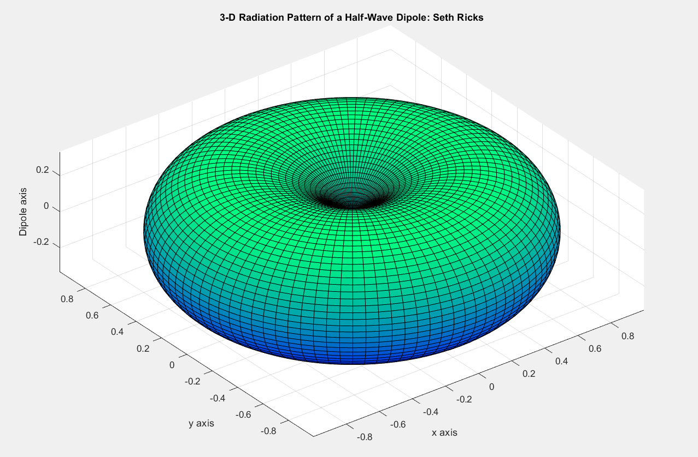

- Determine the total length in feet of a half-wave dipole transmit antenna for an FM radio station operating at a carrier frequency of 91.5 MHz. (Hint: Total length should be between 4 and 6 feet) (2 points.)
$$f=91.5 MHz;c=3*{10}^{8}m/s$$
$$λ=\frac{c}{f}=\frac{3*{10}^{8}m/s}{91.5 MHz} =3.279m*\frac{3.28084ft}{1m}=10.767ft$$
Half-wave $→\frac{λ}{2}=5.378ft$
$$λ=5.378 ft$$

- Determine the vertical antenna height in feet of a quarter-wave monopole transmit antenna for an AM radio station operating at a carrier frequency of 590 kHz. (Hint: Antenna vertical height should be between 330 to 430 feet) (2 points.)
$$f=590 kHz;c=3*{10}^{8}m/s$$
$$λ=\frac{c}{f}=\frac{3*{10}^{8}\frac{m}{s}}{590 kHz}=508.47*\frac{3.28084ft}{1m}=1668.22ft$$
Quarter-wave$→\frac{λ}{4}=417.06 ft$
$$λ=417.06 ft$$

- Calculate the antenna radiation efficiency in percent for a half-wave dipole antenna made of circular copper wire operating at a frequency of 100 MHz. For the copper wire use a radius of 0.4 mm, a total wire length of λ/2, with $μ=4π×{10}^{-7} H/mand σ=5.8×{10}^{7} S/m$. To calculate $R_{loss}$ use the following equation for a circular wire of length l and radius a: $R_{loss}=\frac{l}{2πa}\sqrt{\frac{πfμ}{σ}}.$ (Hint: Efficiency should be > 95%) (5 Points.)

$$R_{loss}=\frac{l}{2πa}\sqrt{\frac{πfμ}{σ}}=\frac{1}{2π(0.4*{10}^{-3}m)}\sqrt{\frac{π(100*{10}^{6}Hz)(4π*{10}^{-7}H/m)}{5.8*{10}^{7}S/m}}=1.038Ω$$
Half-Wave Dipole Antenna$→R_{rad}≈73Ω$
$ξ=\frac{P_{rad}}{P_{total}}=\frac{I^{2}R_{rad}}{{I^{2}R_{rad}+I}^{2}R_{loss}}=\frac{R_{rad}}{{R_{rad}+R}_{loss}}=\frac{73Ω}{73Ω+0.944Ω}=0.986$;
$ξ=98.6\%$

